3. What is Pearson’s R?

Answer-->

Pearson Correlation Coefficient determines linear relationship/correlation between two variables.
- It’s values ranges from -1 to 1.
- 0 to 1, signifies positive correlation, means with one variable, other variable also increases.
  - e.g. population and resource requirements.
- -1 to 0, signifies negative correlation, means with increase in one variable, other variable decreases.
  - e.g. life and price of a non-remodificable/resuable product.
- 0, signifies no correlation between variables.
  - e.g. new additional feature and supply chain of a product.
- -1 and 1, signifies perfect correlation, either negative or positive respectively.

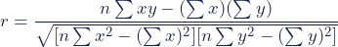

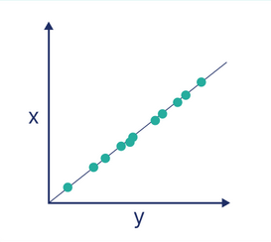
Perfect positive correlation

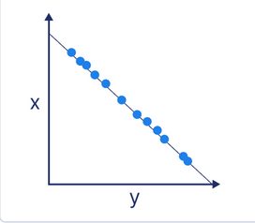
Perfect negative correlation

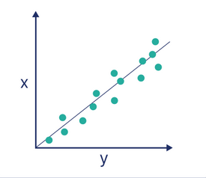
Strong positive correlation

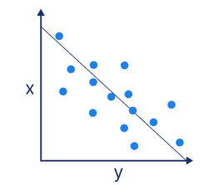
Strong negative correlation

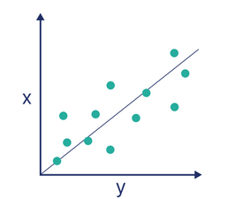
Weak positive correlation

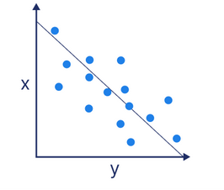
Weak negative correlation

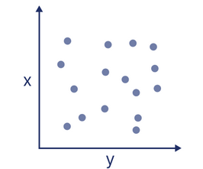
No Correlation

